## 1D NMR FID & Spectrum Raw Data Representation in the Rubtsov and Wishard XSDs and in PSI

This is a test on what tools we can use to compare xml and xsd structures of our different nmrML lineages and visualize design differrences. In this case I have compared the way the nmr raw data (FID and 1D Spectrum) is represented in the two NMR-ML precessors (Rubtsov and Wishard MLs) and how (mass-) spectral data is captured in the PSI mzML. For each storage format, I show the corresponding xsd sections in a graphical way, the xsd code section and a snippet of an xml example for concrete illustration.

Birmingham NMR:

Xsd:

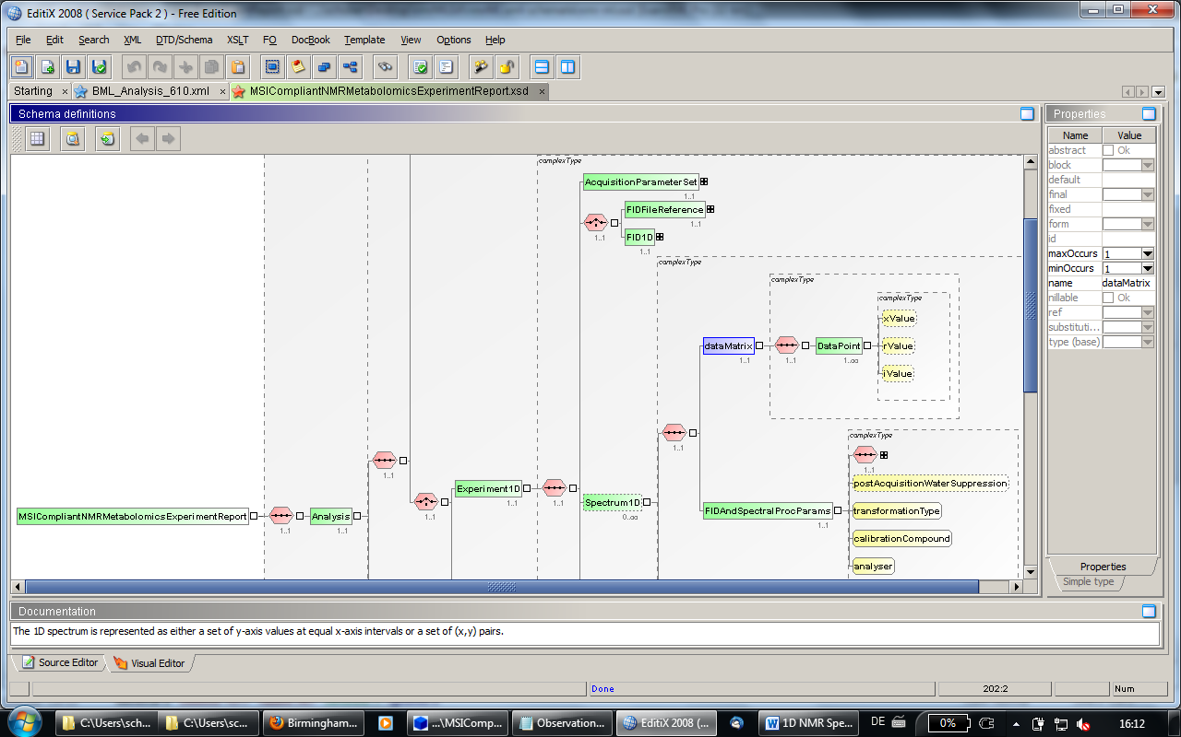

xml example:  
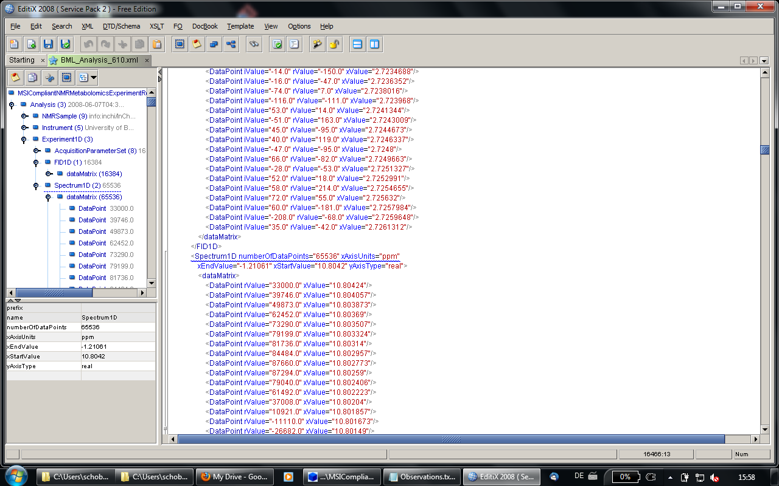

Wishard NMR:

Xsd:

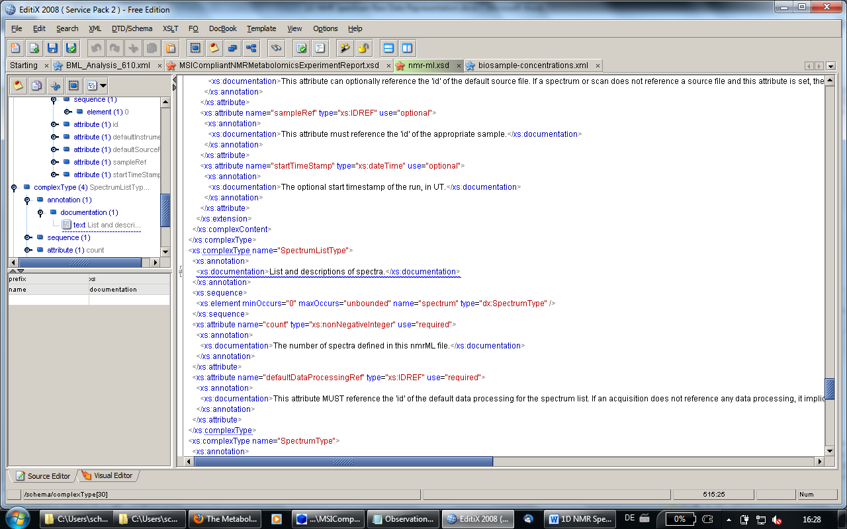

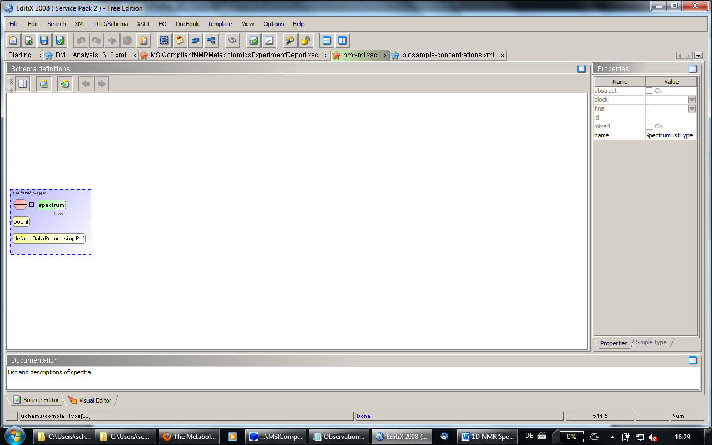

Xml example:

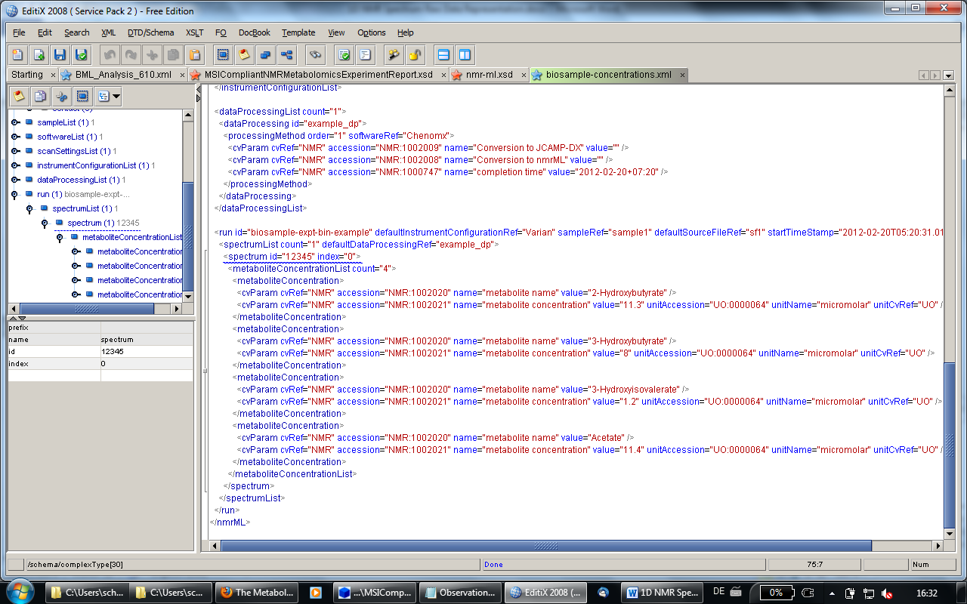

Here is what PSI did in its mzML schema:

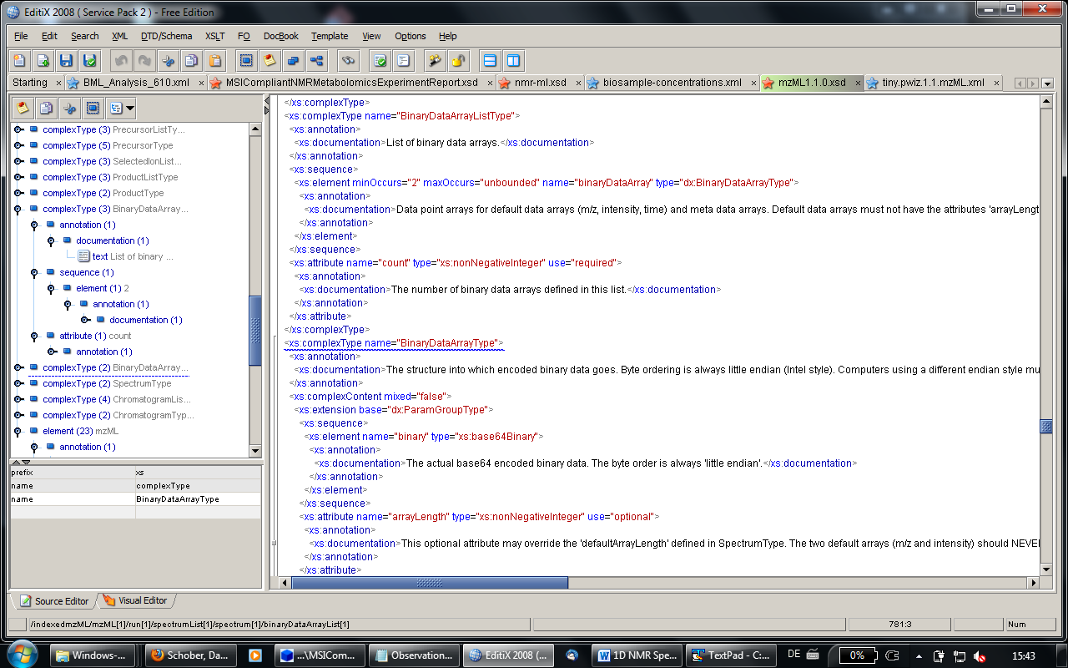

In the xml example they have the raw data in as a 64bit encoded. This is much more compact yet still reproduceable.

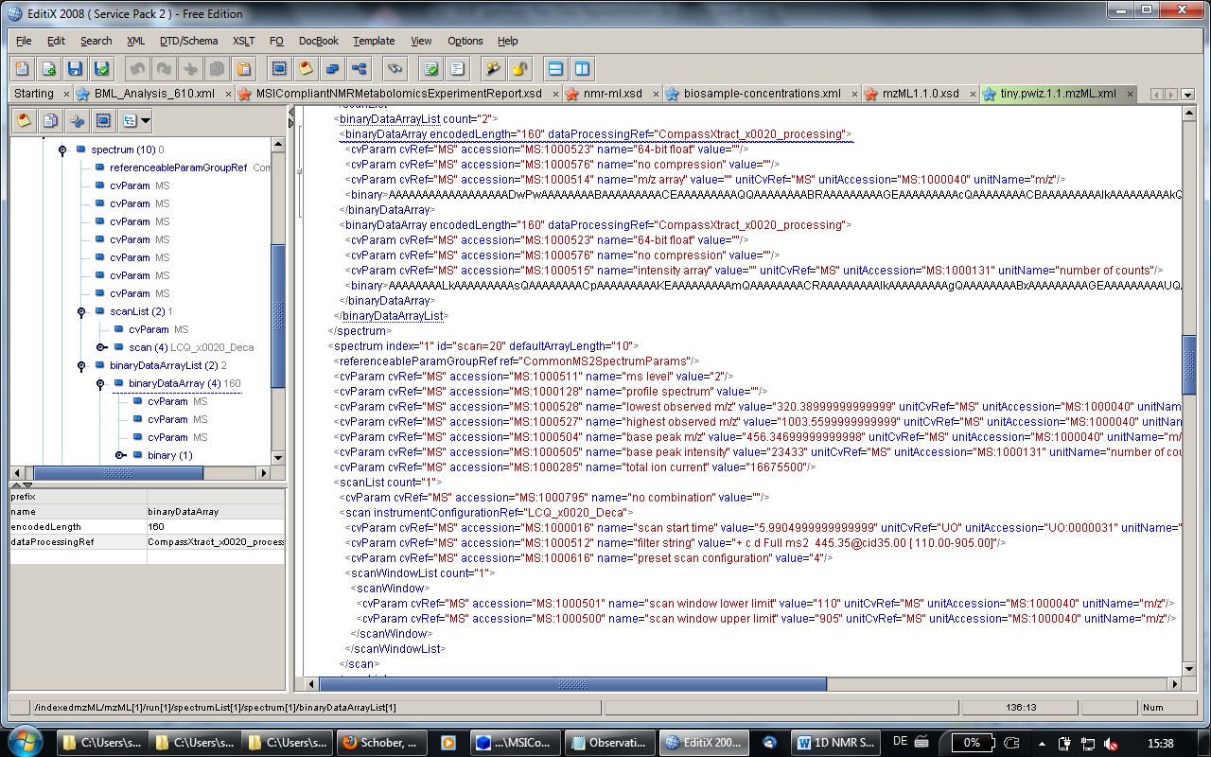

Comparison in another tool (ExamXMLpro):

